Kenora Adams
Professor Kemp
Freshmen Writing
March 18, 2017
Abortion Rights
Disputes as to whether the Affordable Care Act should feature abortion, and more so, cover members of the Congress as well as their staffers has a critical tussle for the U.S. Conference of Catholic Bishops who recently joined the discussion on abortion rights. Whereas the marketplace currently features private health insurance policies that cover abortion services, with exception of certain states, the current federal healthcare plan bars the use of federal funds on plans that do not feature abortions. On the other hand, abortion-rights supporters have been up in arms stating that these restrictions are in contrary to the Bipartisan Budget Act of 2013 featured under the Federal Employees Health Benefits program (Waxman).
According to the Pew Research Center, at least four-in-ten Americans, 44 percent, feel that abortion is morally wrong while 19 percent have come to accept it. Shifting to religious affiliations, approximately 76 percent of white evangelical Protestants have no room for abortion even though 23 percent of the religious folk agree that abortion is medically necessary when it is a matter of life and death. More variations on the religious front can be seen in the graph below (Lipka and Gamlich).
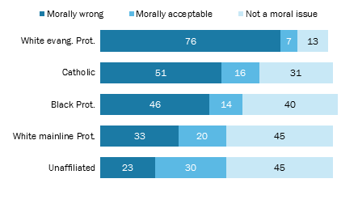
Even though not everything concerning abortion can be captured in hypotheticals or the abstract understanding currently in use to support or go against prolife, it is a key to point out that women’s rights on this front must not be politicized as is the case with both political parties in the U.S. It is equivocal to mention that politicians have been on the forefront in using the subject of abortion to gain votes but never to assist the women on the ground. Ann Scheilder, the current vice president of Pro-Life Action League, points out that recent times have become obese with rulings permitting the killing of children by endorsing abortion of the unborn child having recognized the provisions of Human Rights in the context of an infant as opposed to when still in its mother’s womb (Craig and David 189)..
Amnesty International, a non-governmental organization dealing with human rights, does not endorse universal access to this procedure. Despite these remarks drawing attention from the Vatican, Amnesty International was keen to clarify that decriminalizing the health of the mother in place of the unborn child was medically illogical and, therefore, advised that the priority be placed on the mother. In return, the Vatican has been reported to urge its followers to refrain from dealings with Amnesty International though that has not taken much effect since the statement was made in 2007 (Amnesty International).
While the focus for many has largely been on the rights of the unborn, a number of abortion rights supporters, including NARAL Pro-Choice America, have requested the Department of Justice to look into adding a politically loaded phrase dubbed “domestic terrorism”. This follows the shooting in Colorado Springs where a man allegedly opened fire in a parental planning clinic thereby wounding nine and killing three people in the process. The president of the movement, Ilyse Hogue, stated that they were hoping the investigation would yield interest in the political term and ultimately have it included in the federal laws (Milligan).
Abortion happens, in most instances, in the first twenty-eight days of the pregnancy (Luker 118). The issue of abortion is one that has been of concern in the United States and has raised the concern from many people. However, a majority of the Americans feel that life is sacred and that people should not be granted the right to abort. A great example of a politician who feels that abortion should be banned completely is the current president of the United States, Donald Trump. According to recent findings, at least 59 percent of American adults feel that abortion should be legalized. This is in comparison to the 37 percent who are of the opinion that the procedure should be illegal (Jelen 168).
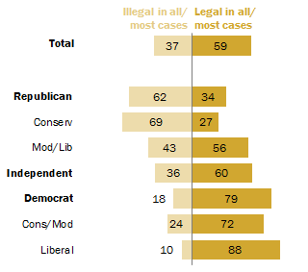
Additionally, democrats have been observed to have a higher likelihood of legalizing the procedure in comparison to Republicans, and this can be seen by extension on the President Trump’s agenda towards abortion. At least 88 percent of Democrats vouch for the legalization of abortion. In the same breadth, 88 percent of post graduate degree holders join forces with the ruling of Roe V. Wade in comparison to 74 percent of those with first degrees and 62 percent of those having reached high school education or less. When it comes to gender, there are no significant differences regarding this question (Lipka and Gamlich).
Just like in the 18th century, abortion was a legal process practiced by many and it was until the 19th century that the tables were turned thereby introducing prolife laws which are currently very familiar with most folks in the postmodern society (Segers and Timothy 127). The concern is, however, not aimed at solving the problem that people have in the society, the main aim is usually to get elected to the office.

Works Cited

Amnesty International. "My Body My Rights." My Body My Rights. Amnesty International, 4 Apr. 2007. Web. 05 Apr. 2017.
Craig, Barbara Hinkson., and David M. O'Brien. Abortion and American Politics. Chatham, Chatham House Publishers, Inc., 2013. Print.
Jelen, Ted G. Perspectives on the Politics of Abortion. Westport, CT: Praeger, 2015. Print.

Lipka, Michael., and Gamlich John. "5 Facts About Abortion". Pew Research Center. N. p., 2017. Web. 5 Apr. 2017.
Luker, Kristin. Abortion and the Politics of Motherhood. Berkeley, Calif.: U of California Pr., 2012. Internet resource.
Milligan, Susan. "Is Abortion a Human Right?" U.S. News & World Report. U.S. News & World Report, 02 Dec. 2015. Web. 05 Apr. 2017.
Segers, Mary C., and Timothy A. Byrnes. Abortion Politics in American States. Amonk: M. E. Sharpe, 2015. Internet resource.

Waxman, Judy. " Stakeholders Split Along Familiar Lines In Debate Over Abortion Coverage For Congress, Staffers - National Partnership For Women & Families | Women's Health Policy Report ". Go.nationalpartnership.org. N. p., 2017. Web. 5 Apr. 2017.

